1. We made new default values

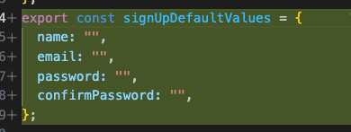

1. New sign-up form and components

And almost everything was literally copied and modified from what we did in the sign in part.